Introduction to HTML

What is HTML?

* HTML, otherwise known as HyperText Markup Language, is the language used to create web pages.
* Using HTML, you can create a Web page with text, graphics, sound, and video.

Tags

The essence of HTML programming is tags.

A tag is a keyword enclosed by angle brackets (Example: <|> )

There are opening and closing tags for many but not all tags; The affected text is between the two tags.

The opening and closing tags are teh same command except the closing tag contains an additional forward slash /

For example, the expression <b> Warning <b> would cause the word 'Warning' to appear in bold face on a web page.

Nested Tags

Whenever you have HTML tags within other HTML tags, you must close the nearest tag first.

**Example:**   
<H1><I> The Nation </I></H1>

Structure of a Web Page

All web pages share a common structure.

All web pages should contain a pair of <HTML><HEAD><TITLE> and <BODY> tags.

Example

<HTML>

<HEAD>

<TITLE> Example </TITLE>

</HEAD>

<BODY>This is where you would include the text and images in your web page.

</BODY>

</HTML>

The <TITLE> Tag

Choose the title of your web page carefully; the title of a web page determines its ranking in certain search engines.

The title will also appear on favorite lists, history lists and bookmark lists to identify your page.

Text Formatting

Manipulating text in HTML can be tricky; Oftentimes, what you see is NOT what you get

For instance, special HTML tags are needed to create paragraphs, move to the next line and create headings.

Text Formatting Tags

<B> **Bold Face** </B>  
<I> *Italics* </I>  
<U> Underline </U>  
<P> New Paragraph </P>  
<BR> Next Line

Changing the font

The expression <FONT FACE = "fontname"> ... </FONT> can be used to change the font of the enclosed text.

To change the size of text use the expression <FONT SIZE=n> .... </FONT> where n is a number between 1 and 7

To change the color, use <FONT COLOR="red"> .... </FONT>  
The color can also be defined using hexadecimal representation (Example: #ffffff )

These attributes can be combined to change the font, size and color of the text all at once; For example, <FONT SIZE=4 FACE="Courier" COLOR="red"> .... </FONT>

Headings

Web pages are typically organized into sections with headings; To create a heading use the expression <Hn> .... </Hn> where n is a number between 1 and 7

In this case, the 1 corresponds to the largest size heading while the 7 corresponds to the smallest size

Aligning Text

The ALIGN attribute can be inserted in the <P> and <Hn> tags to right justify, center or left justify the text.

For example, <H1 ALIGN=CENTER> The New York Times </H1> would create a centered heading of the largest size.

Comment Statements

Comment statements are notes in the HTML code that explain the important features of the code

The comments do not appear on the web page itself but are a useful reference to the author of the page and other programmers

To create a comment statement use the <!-- .... --> tags.

The Infamous Blink Tag

It is possible to make text blink using the <BLINK> ... </BLINK> tag

However, it is best to use this feature at most sparingly or not at all; What seems like a good idea to a web designer can become very annoying to a web user.

The <BLINK> tag is not supported by internet explorer.

# Page Formatting

To define the background color, use the BGCOLOR attribute in the <BODY> tag

To define the text color, use the TEXT attribute in the <BODY> tag

To define the size of the text, type <BASEFONT SIZE=n>

### Example

<HTML>

<HEAD>

<TITLE> Example </TITLE>

</HEAD>

<BODY BGCOLOR**="black"** TEXT**="white"**>

<BASEFONT SIZE**=7**> This is where you would include the text and images in your web page.

</BODY>

</HTML>

## **Inserting Images**

Type <IMG SRC = "image.ext">, where image.ext indicates the location of the image file

The WIDTH=n and HEIGHT=n attributes can be used to adjust the size of an image

The attribute BORDER=n can be used to add a border n pixels thick around the image

### Alternate Text

Some browsers don't support images. In this case, the ALT attribute can be used to create text that appears instead of the image.

Example:   
<IMG SRC="satellite.jpg" ALT = "Picture of satellite">

## **Links**

A link lets you move from one page to another, play movies and sound, send email, download files and more..

A link has three parts: a destination, a label and a target.

To create a link type:

<A HREF**="page.html"**>label</A>

### Anatomy of a Link

<A HREF**="page.html"**>label</A>

In the above link, "page.html" is the destination. The destination specifies the address of the web page or file the user will access when he/she clicks on the link.

The label is the text that will appear underlined or highlighted on the page.

### Example: Links

To create a link to CNN, I would type:

<A HREF**="http://www.cnn.com"**>CNN</A>

To create a link to MIT, I would type:

<A HREF**="https://www.mit.edu.au/"**>MIT</A>

### Changing the color of links

The LINK, VLINK and ALINK attributes can be inserted in the <BODY> tag to define the color of a link

- LINK defines the color of links that have not been visited  
- VLINK defines the color of links that have already been visited  
- ALINK defines the color of a link when a user clicks on it

### Using links to send email

To create a link to an email address, type <A HREF="mailto:email_address">Label</A>

For example, to create a link to send email to myself, I would type: <A HREF="mailto:ktdunn@mit.edu.au">email Katie dunn</A>

# Anchors

Anchors enable a user to jump to a specific place on a website

Two steps are necessary to create an anchor. First you must create the anchor itself. Then you must create a link to the anchor from another point in the document.

To create the anchor itself, type <A NAME="anchor name">label</A> at the point in the web page where you want the user to jump to.

To create the link, type <A HREF="#anchor name">label</A> at the point in the text where you want the link to appear.

### Example: Anchor

image showing link and anchor in web page

## **Ordered Lists**

Ordered lists are a list of numbered items

To create an ordered list, type:

<OL>

<LI> This is step one.

<LI> This is step two.

<LI> This is step three.

</OL>

Here's how it should look on the web:  
1. This is step one.  
2. This is step two.  
3. This is step three.

### More Ordered Lists...

The TYPE=x attribute allows you to change the kind of symbol that appears in the list.  
- A is for capital letters  
- a is for lowercase letters  
- I is for capital roman numerals  
- i is for lowercase roman numerals

### Unordered Lists

An unordered list is a list of bulleted items

To create an unordered list, type:

<UL>

<LI> First item in list.

<LI> Second item in list.

<LI> Third item in list.

</UL>

Here's how it would look on the web:

* First item in list
* Second item in list
* Third item in list

### More Unordered Lists...

The TYPE=shape attribute allows you to change the type of bullet that appears

circle corresponds to an empty round bullet

square corresponds to a square bullet

disc corresponds to a solid round bullet; this is the default value.

# Forms

What are forms?

- A HTML form is an area of the document that allows users to enter information into fields.  
- A form may be used to collect personal information, opinions in polls, user preferences and other kinds of information.

There are two basic components of a web form: the shell, the part that the user fills out and the script which processes the information.

HTML tags are used to create the form shell. Using HTML you can create text boxes, radio buttons, check-boxes, drop-down menus and more..

### Example: Form

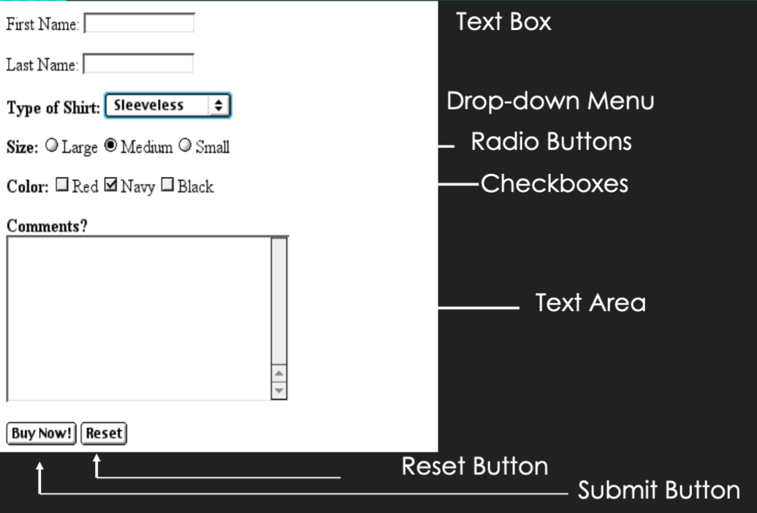

form example in web page

### The Form Shell

A form shell has three important parts:

- The <FORM> tag, which includes the address of the script which will process the form.  
- The form elements, like text boxes and radio buttons.  
- The submit button which triggers the script to send the entered information to the server.

### Creating the Shell

To create a form shell, type <FORM METHOD=POST ACTION="script_url">where "script_url" is the address of the script.

Create the form elements.

End with a closing </FORM> tag.

### Creating Text Boxes

To create a text box, type <INPUT TYPE="text" NAME="name" VALUE="value" SIZE=n MAXLENGTH=n>

The NAME, VALUE, SIZE and MAXLENGTH attributes are optional

### Text Box Attributes

The NAME attribute is used to identify the text box to the processing script.

The VALUE attribute is used to specify the text that will initially appear in the text box.

The SIZE attribute is used to define the size of the box in characters.

The MAXLENGTH attribute is used to define the maximum number of characters that can be typed in the box.

### Example: Text Box

First Name: <INPUT TYPE="text" NAME="FirstName" VALUE="First Name" SIZE=20> <BR><BR>  
Last Name: <INPUT TYPE="text" NAME="LastName" VALUE="Last Name" SIZE=20>

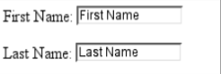

text box web example

Here is how it would look on the web,

### Creating Radio Buttons

To create a radio button, type <INPUT TYPE="radio" NAME="name" VALUE="data"> Label, where "data" is the text that will be sent to the server if the button is checked and "Label" is the text that identifies the button to the user.

### Example: Radio Buttons

<B> Size: </B>

<INPUT TYPE**="radio"** NAME**="Size"** VALUE**="Large"**>Large

<INPUT TYPE**="radio"** NAME**="Size"** VALUE**="Medium"**>Medium

<INPUT TYPE**="radio"** NAME**="Size"** VALUE**="Small"**>Small

### Creating Checkboxes

To create a checkbox, type <INPUT TYPE="checkbox" NAME="name"  
VALUE="value">Label

If you give a group of radio buttons or checkboxes the same name, the user will only be able to select one button or box at a time.

### Example: Checkboxes

<B> Color: </B>

<INPUT TYPE**="checkbox"** NAME**="Color"** VALUE**="Red"**>Red

<INPUT TYPE**="checkbox"** NAME**="Color"** VALUE**="Navy"**>Navy

<INPUT TYPE**="checkbox"** NAME**="Color"** VALUE**="Black"**>Black

### Creating Drop-down Menus

To create a drop-down menu, type <SELECT NAME="name" SIZE=n MULTIPLE>

Then type <OPTION VALUE= "value">Label

In this case the SIZE attribute specifies the height of the menu in lines and MULTIPLE allows users to select more than one menu option

### Example: Drop-down Menu

<B> WHICH IS FAVOURITE FRUIT:</B>

<SELECT>

<OPTION VALUE**="MANGOES"**>MANGOES

<OPTION VALUE**="PAPAYA"**>PAPAYA

<OPTION VALUE**="GUAVA"**>GUAVA

<OPTION VALUE**="BANANA"**>BANANA

<OPTION VALUE**="PINEAPPLE"**>PINEAPPLE

<SELECT>

### Creating a Submit Button

To create a submit button, type <INPUT TYPE="submit">

If you would like the button to say something other than submit, use the VALUE attribute

For example, <INPUT TYPE="submit" VALUE="Buy Now!"> would create a button that says "Buy Now!"

### Creating a Reset Button

To create a reset button, type <INPUT TYPE="reset">

The VALUE attribute can be used in the same way to change the text that appears on the button.

## **Tables**

Tables can be used to display rows and columns of data, create multi-column text, captions for images and sidebars

The <TABLE> tag is used to create a table; the <TR> tag defines the beginning of a row while the <TD> tag defines the beginning of a cell

### Adding a Border

The BORDER=n attribute allows you to add a border n pixels thick around the table

To make a solid border color, use the BORDERCOLOR="color" attribute

To make a shaded colored border, use BORDERCOLORDARK="color" and BORDERCOLORLIGHT="color"

### Creating a Simple Table

<TABLE BORDER**=10**>

<TR>

<TD>One</TD>

<TD>Two</TD>

</TR>

<TR>

<TD>Three</TD>

<TD>Four</TD>

</TR>

</TABLE>

Here's how it would look on the web:

basic table

### Dividing Table into Horizontal Sections

You can also create a horizontal section consisting of one or more rows. This allows you to format the rows all at once.

To create a horizontal section, type <THEAD>, <TBODY> or <TFOOT> before the first <TR> tag of the section.

Netscape does not support these tags.

### Controlling Line Breaks

Unless you specify otherwise a browser will divide the lines in a cell as it sees fit.

The NOWRAP attribute placed within the <TD> tag forces the browser to keep all the text in a cell on one line.

Example:   
<TD NOWRAP>Washington, D.C

### Parting Words...

If you can imagine a way to lay out your page, chances are it is possible using HTML

When in doubt, use a HTML reference.